**Real-Time River Water Quality Monitoring and Control System**

INTRODUCTION:

Now a day’s Internet of things (IoT) is an innovative technological phenomenon. It is shaping today’s world and is used in different fields for collecting, monitoring and analysis of data from remote locations. IoT integrated network if everywhere starting from smart cities, smart power grids, and smart supply chain to smart wearable

Water quality monitoring has gained more interest among researchers in this twenty-first century. Numerous works are either done or ongoing in this topic focusing on various aspects of it. The key theme of all the projects was to develop an efficient, cost-effective, real-time water quality monitoring system which will integrate wireless sensor network and internet of things.

PROPOSED SYSTEM:

The main aim is to develop a system for continuous monitoring of river water quality at remote places using wireless sensor networks with low power consumption, low-cost and high detection accuracy. pH, conductivity, turbidity level, etc. are the limits that are analyzed to improve the water quality.

* To measure water parameters such as pH, dissolved oxygen, turbidity, conductivity, etc. using available sensors at a remote place
* To assemble data from various sensor nodes and send it to the base station by the wireless channel.
* To simulate and evaluate quality parameters for quality control.

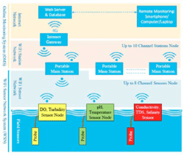

Sensors for monitoring:

* pH sensor:

The pH of thing is a useful constant to display because graduate and low pH levels can hump large effects on the author. The pH of a statement can grasp from 1 to 14. A pH sensor is an instrumentation that measures the hydrogen-ion density in a bleach, indicating its tartness or alkalinity. Its constitute varies from 0 to 14 pH. Uttermost 164 pH values also process the solubility of elements and compounds making them cyanogenetic. Mathematically pH is referred as, pH = -log [H+]

* Turbidity sensor:

Turbidity train sensor is victimised to measure the clarity of element or muddiness utter in the water. The muddiness of the open cut food is ordinarily between 255 NTU. Irrigate is visibly at levels above 80 NTU. The standards for intemperance liquid is 130 NTU to 250 NTU. The turbidity device consists of soft sender and acquirer, the transmitter needs to transmit unsubtle bright, it is said to be turbid. The consequence of turbidity is a reduction in water clarity, aesthetically unpleasant, decreases the rate of photosynthesis, increases water temperature.

* Temperature sensor:

Here DS18B20 is old as the temperature device. Usually, its present use to perceive the temperature of the life, if we site the device wrong the conductor electrode and placed into the H2O, it can discover the temperature of H2O also. The normal temperature of the people is (25 -30)°C.

* LCD display:

LCD (Liquid Crystal Display) impede is a flat brace electronic exhibit power and finds in a countywide orbit of applications. A 16x2 LCD demo is the really fundamental power and is rattling commonly victimised in varied devices and circuits. These modules are desirable over heptad segments and otherwise multi-segment LEDs.

* Wi-Fi module:

Wi-Fi is a subject for wireless localized area scheme with devices. Devices that can use Wi-Fi study permit private computers, video-game consoles, smartphones, digital cameras, paper computers, digital frequency players and ultramodern printers. Wi-Fi matched devices can insert to the Cyberspace via a LAN web and wireless make a bushel. Much a reach quantity (or point) has a capableness of around 20 meters (66 feet) indoors and a greater compass outdoors. Wi-Fi subject may be utilised to render the Internet reach to devices that are within the capability of a wireless meshwork that is connected to the Internet.

* Software design:

The proposed water quality monitoring system based on WSN can be divided into three parts:

• IoT platform

• Neural network models in Big Data Analytics and water quality management

• Real-time monitoring of water quality by using IoT integrated Big Data Analytics

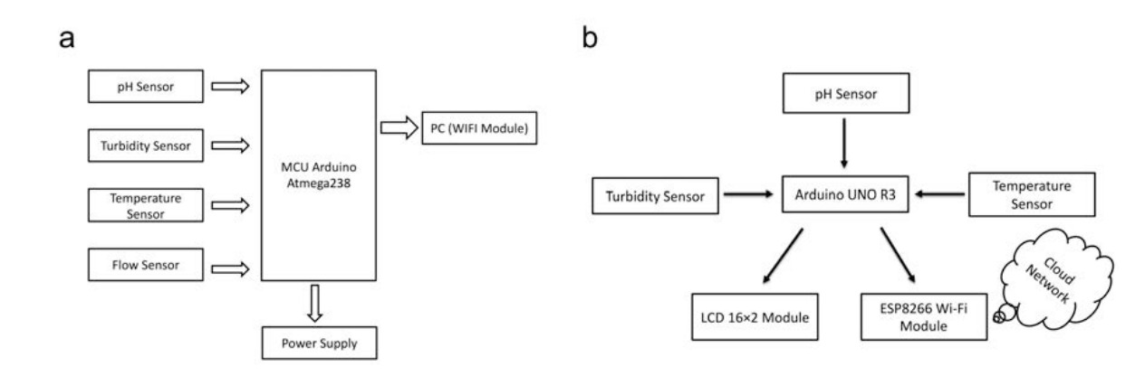

Real-time monitoring of water quality by using IoT integrated Big Data Analytics :

IoT devices use various types of sensors to collect data about turbidity, ORP, temperature, pH, conductivity, etc. of river water continuously. Also, IoT devices have capability to stream the array of collected data wirelessly to the remote Data Aggregator Server in the cloud. Moreover, the volume of semi structured data increases with time in such a velocity that only the Big Data Analytics applications can efficiently store and analyze the data constantly.

The system should be reliable and scalable. So, data management layer will be deployed and operational on the Apache Hadoop cluster. Hadoop helps distributed storing and processing of big data across cluster of computers. Also, such operational environment is horizontally scalable i.e. nodes or computers can be added to a cluster later while volume and velocity of data streaming will be increasing.

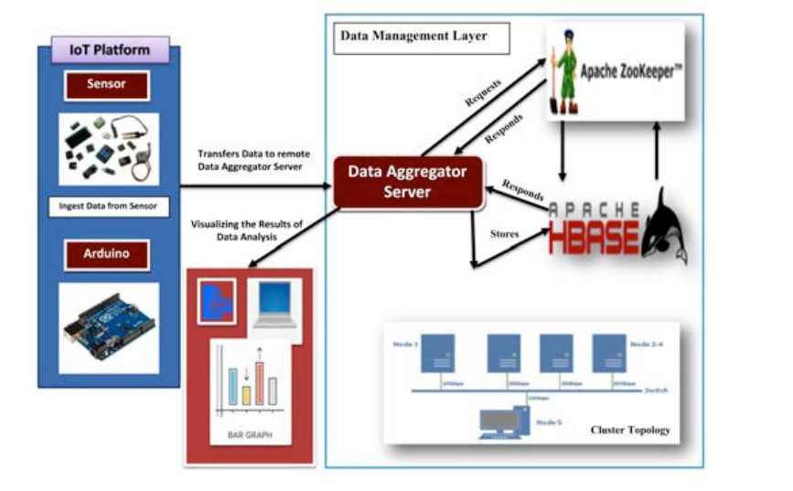

Result:

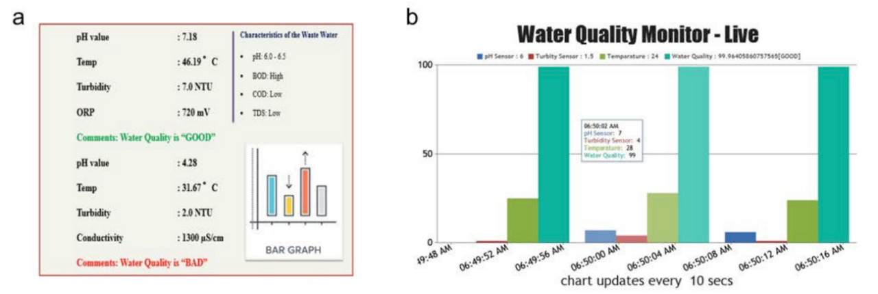

It continuously senses the values of pH, temp, turbidity, and ORP and the resulting values are displayed to the LCD, PC or mobile in real-time. If the acquired value is above the threshold value comments will be displayed as ‘BAD’. If the acquired value is lower than the threshold value comments will be displayed as ‘GOOD’.

BY:

CHANDRA MOHAN (TEAM LEADER)

BARATH RAJ (TEAM MEMBER)

AJAY PRASAD (TEAM MEMBER)

AKASH THOMAS (TEAM MEMBER)